 Assignment – 3

**CSE2010 - Advanced C Programming**

**Class Number:** VL2020210504705 **Slot:** L43+L4 **Name :** Prashanth S **Roll :** 19MID0020

1. Write a C program to create and display a structure with members as employee Name, e Identification Number, Address, designation and salary.

**Program flow**

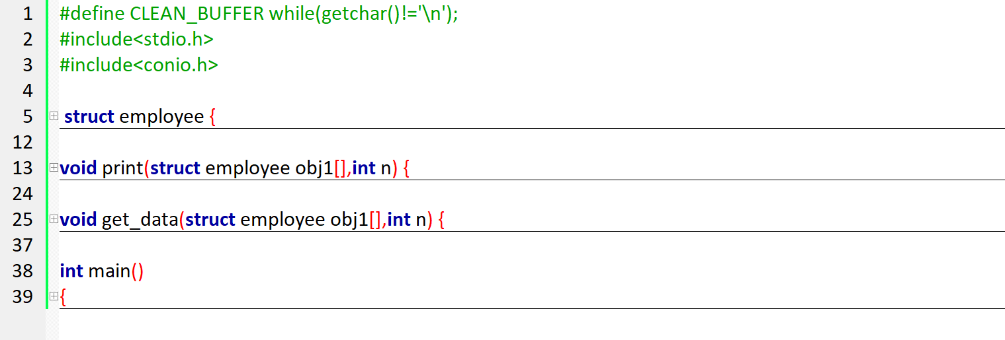

**Code**

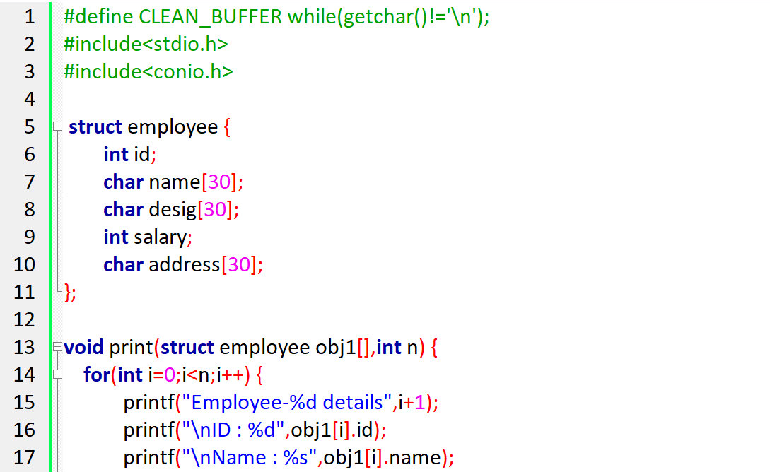

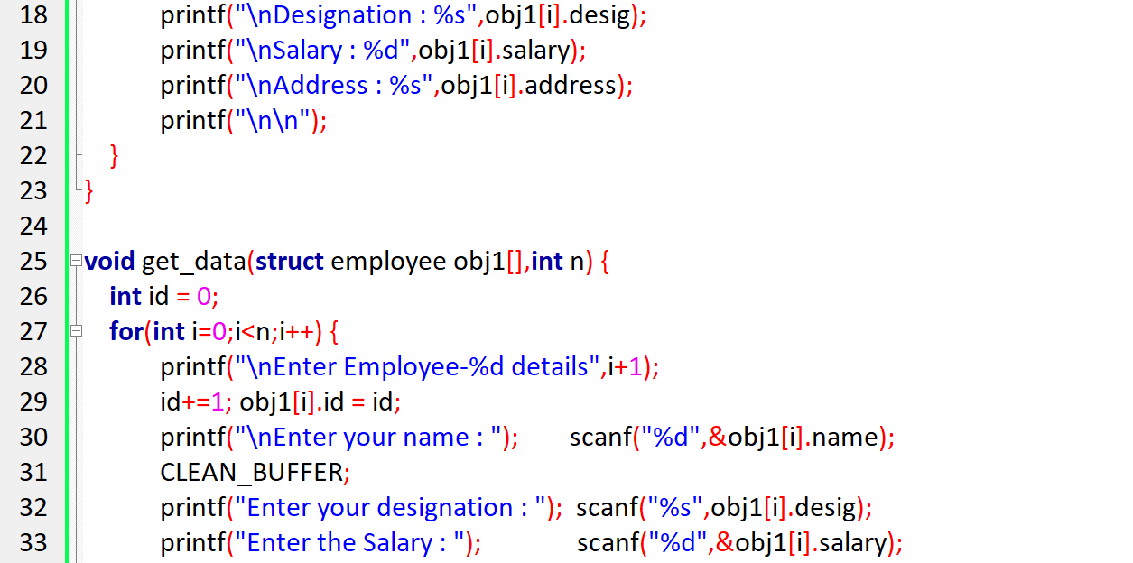

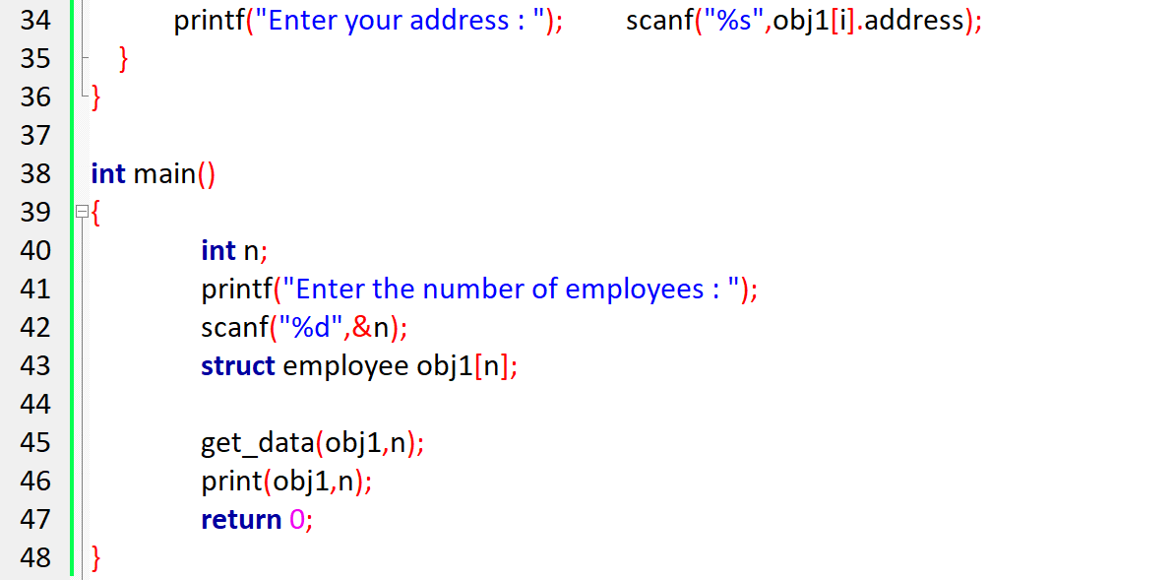

**Output**

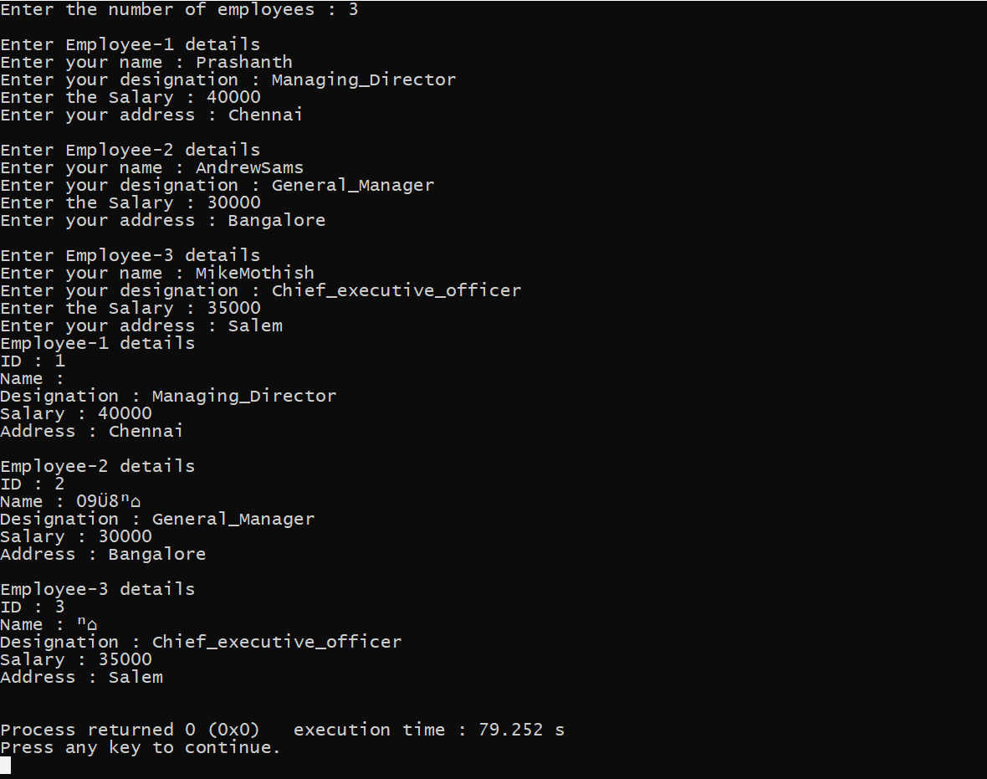

2. With reference to the structure created in Q1, Write a C program to create record for N employees and print the details of the employee with greatest salary.

**Program flow**

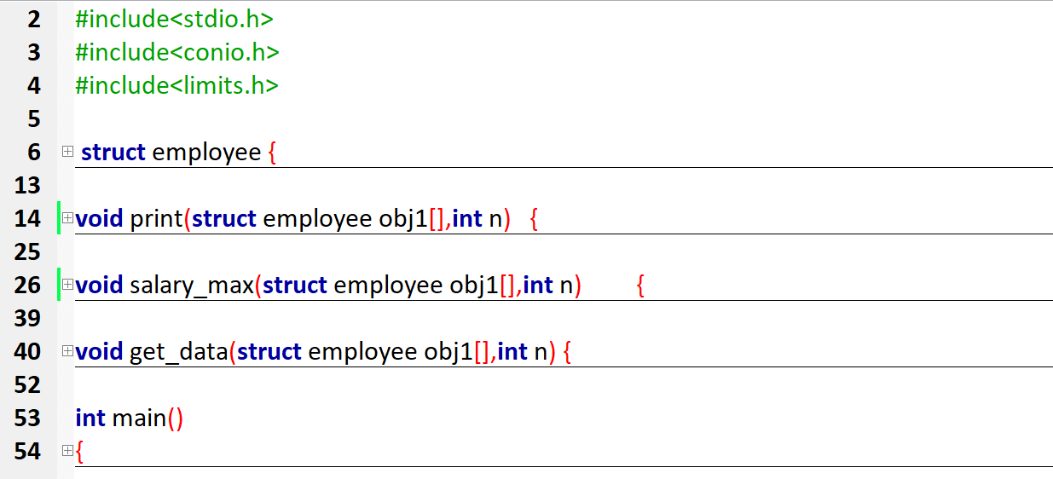

**Code**

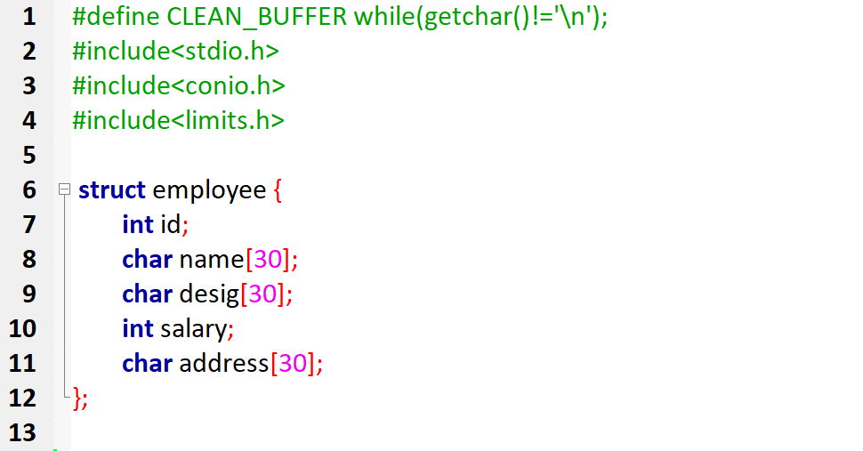

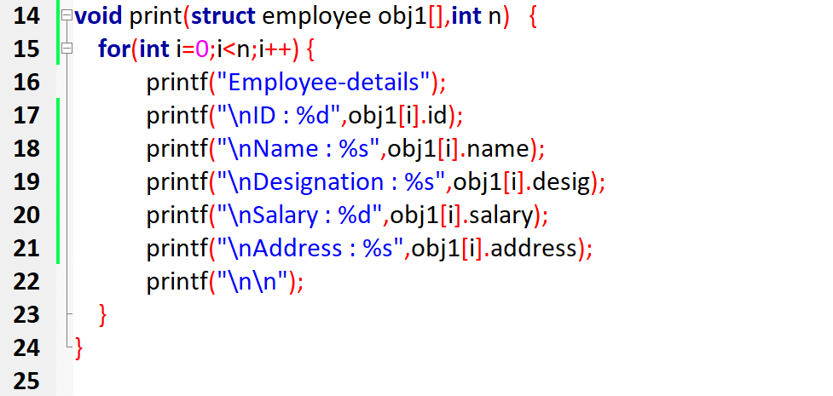 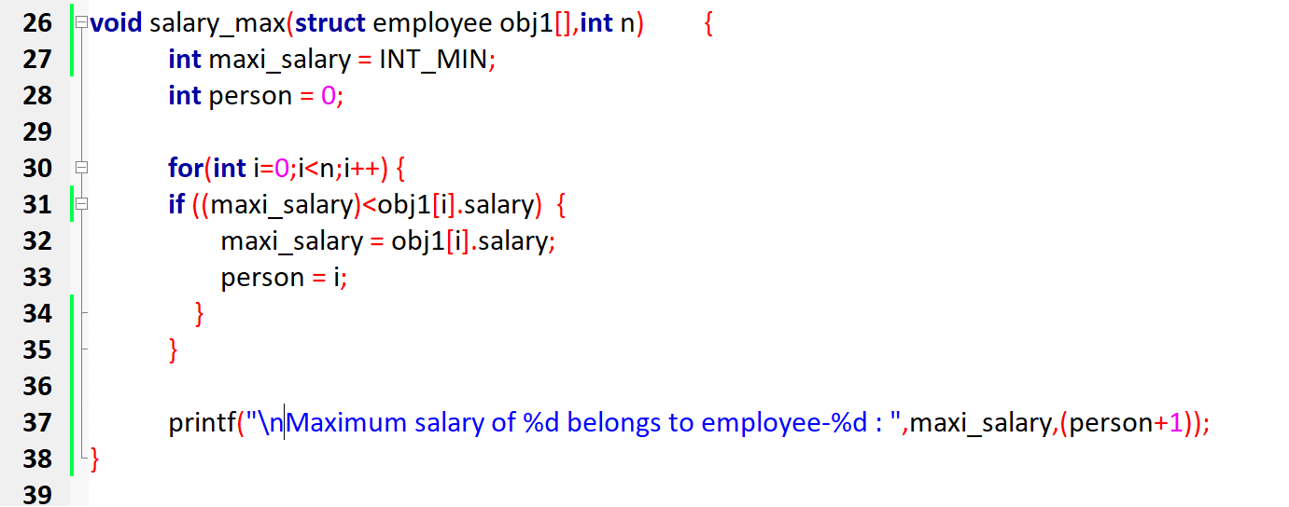

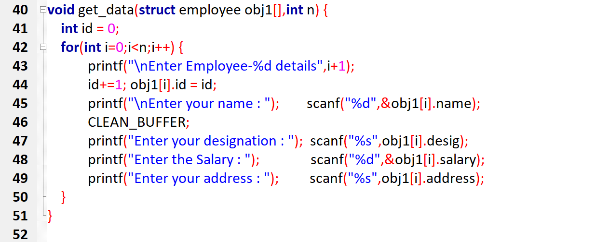

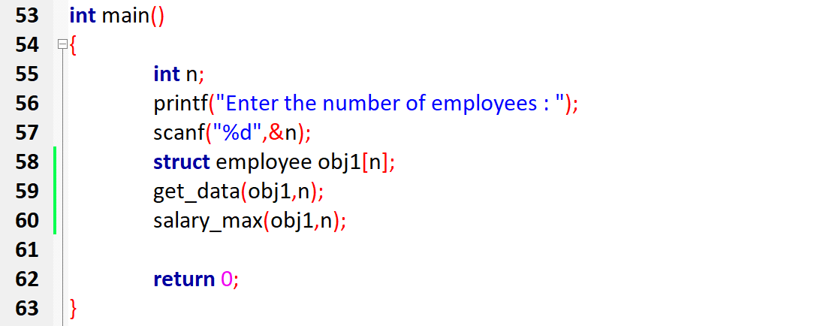

**Output**

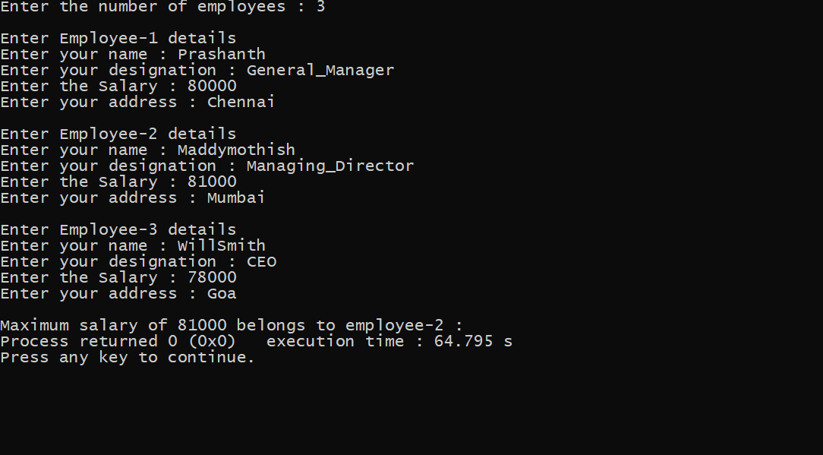

3. With reference to the Q2, Write a C program to do the same task by using pointers to array of structures.

**Program flow**



**Code**

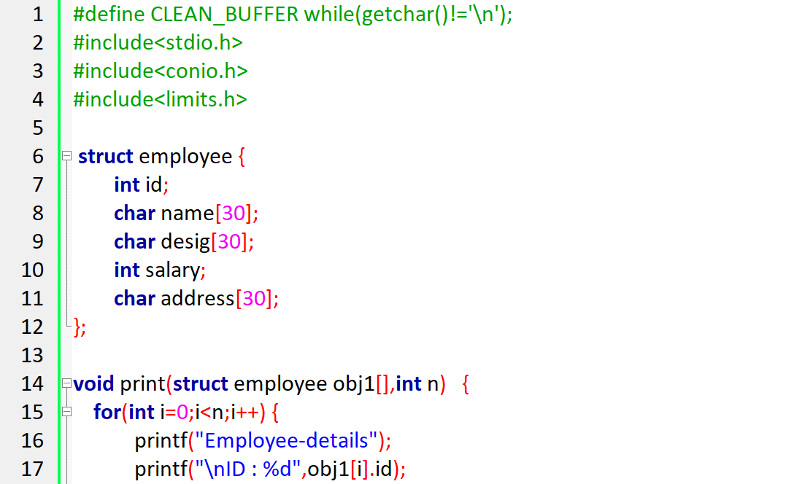

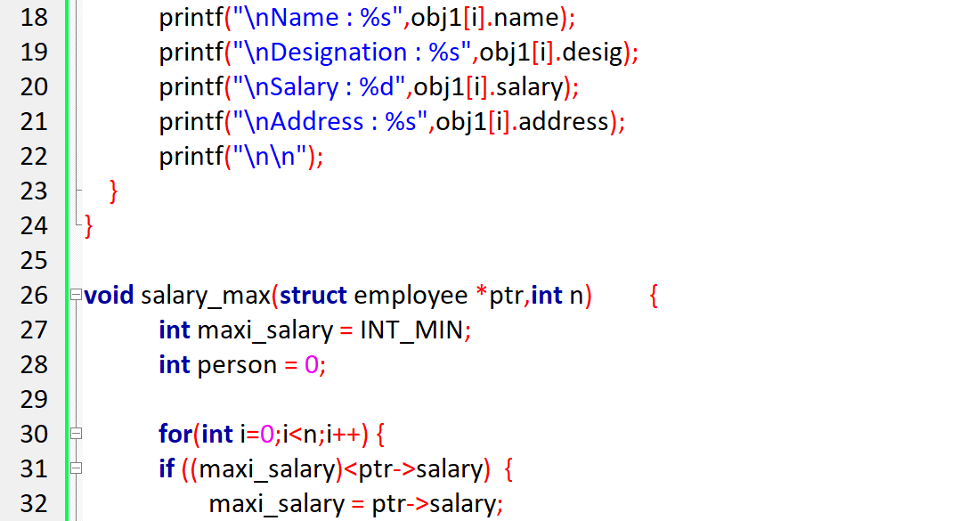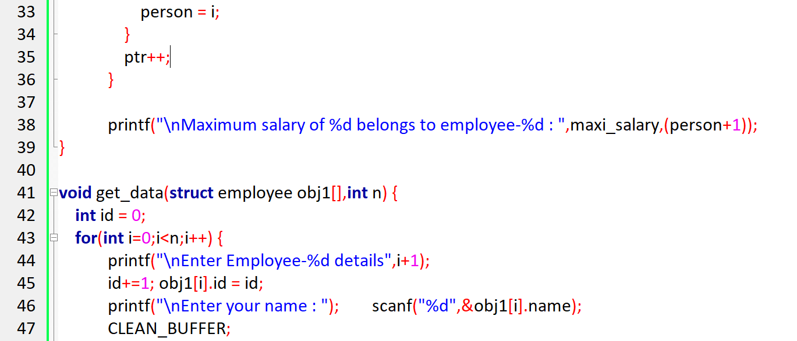

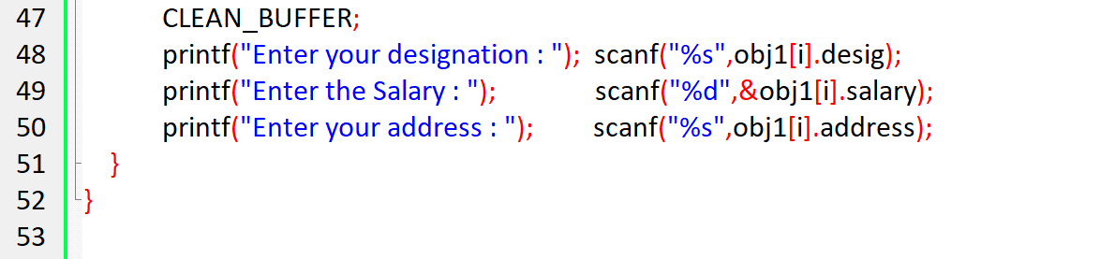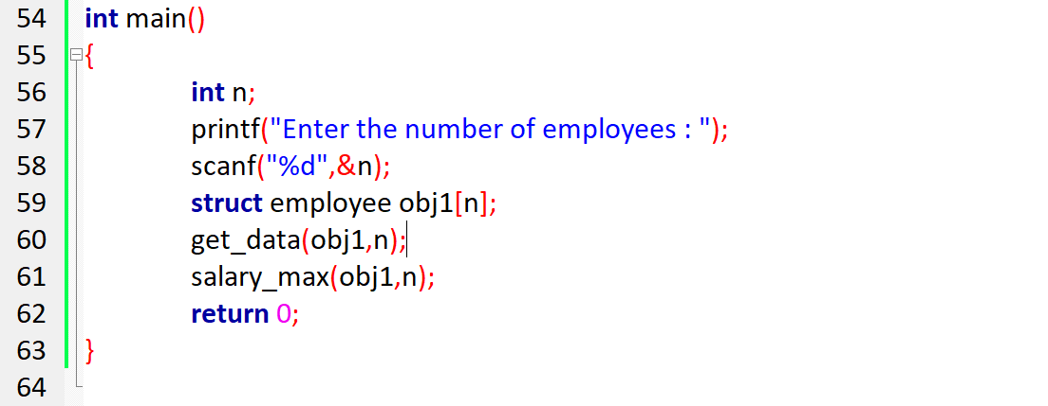

**Output**

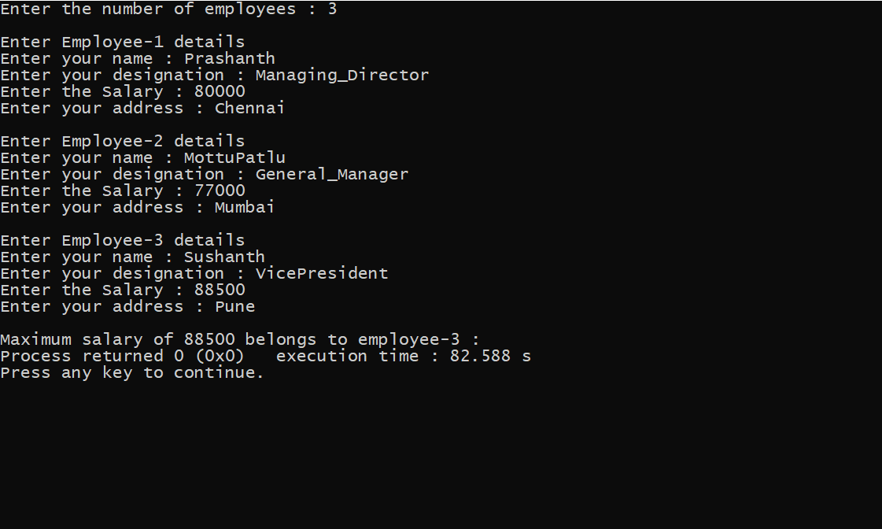

4. Write a C program to define 3 structures as rectangle, square and circle and define their corresponding members. Pass the structure to 3 different functions to calculate its area and print the result.

**Program flow**

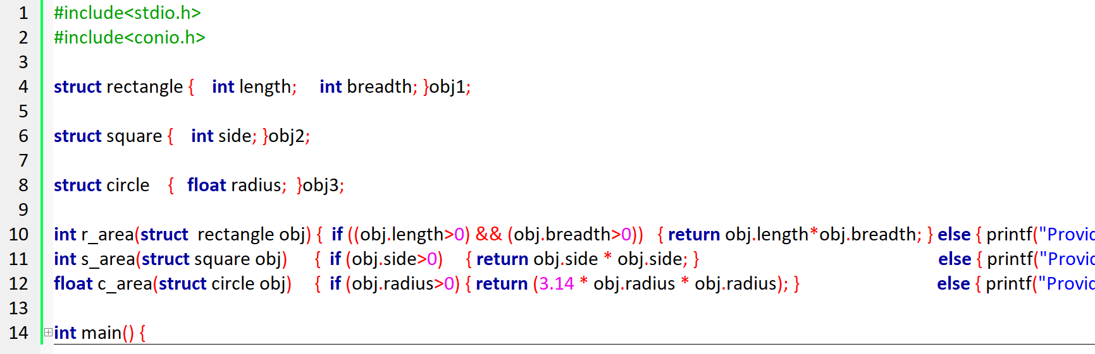

**Code**

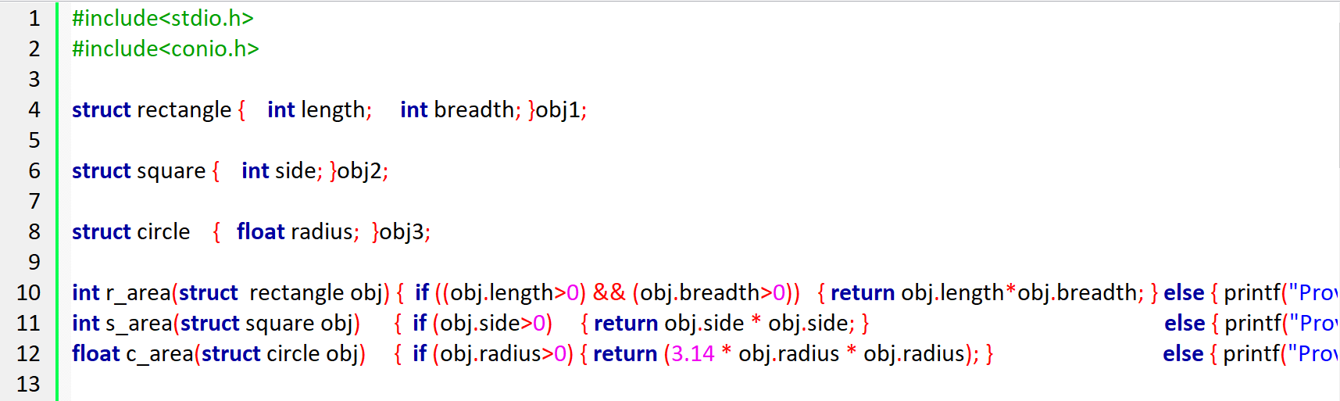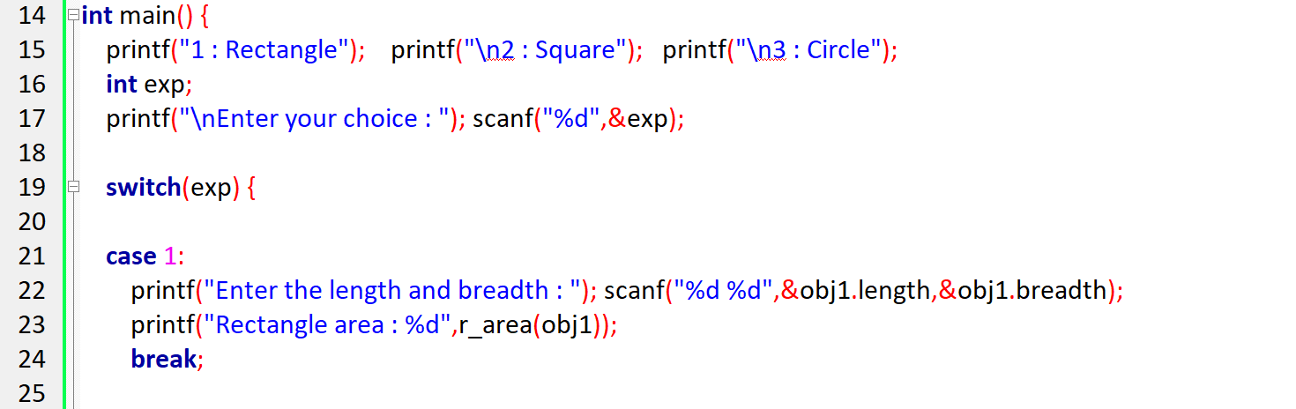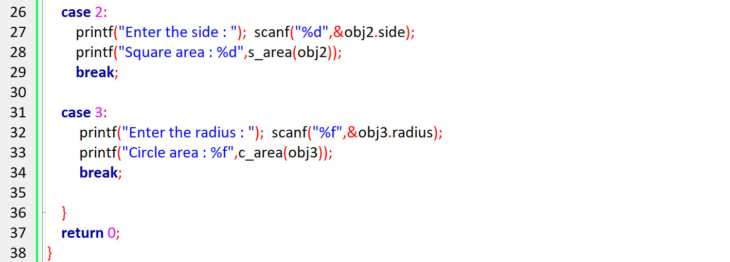

**Output**

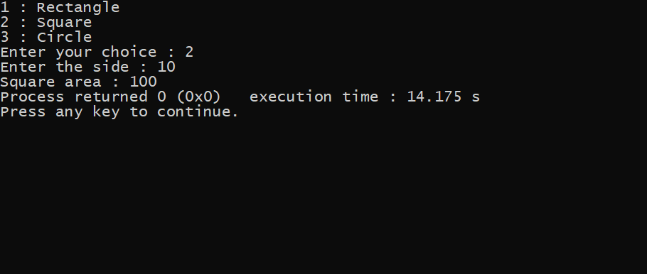

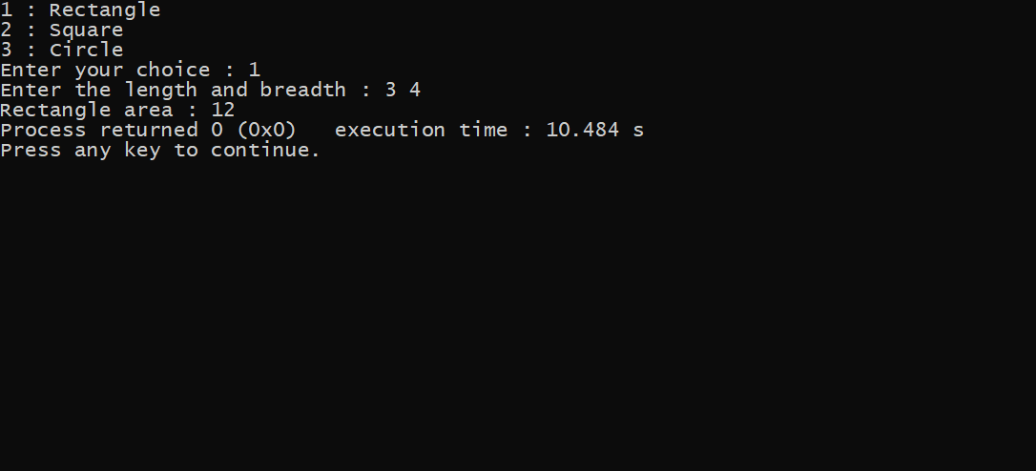

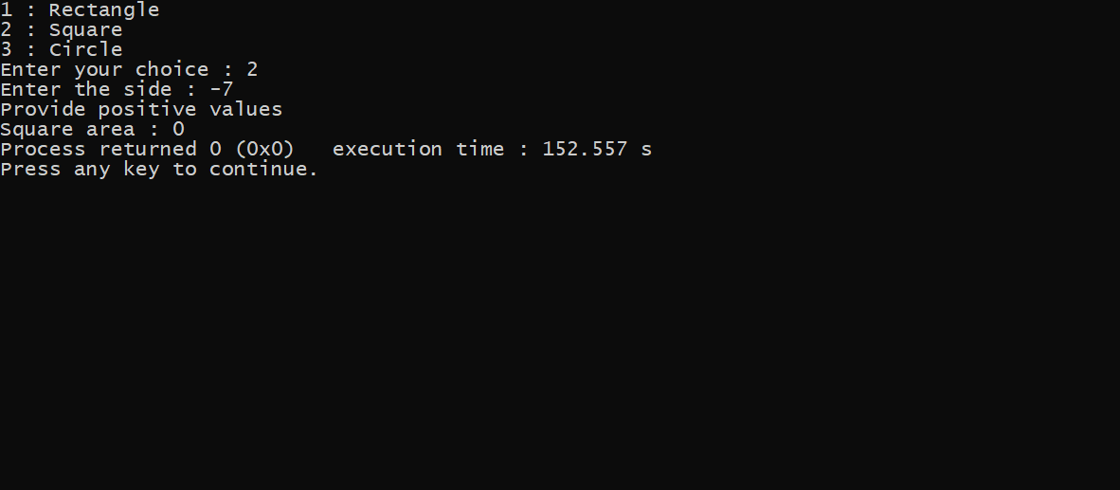

5. Create a structure customer with members name, Id and amount. Also add appropriate functions to deposit, withdraw and check balance. Write a C program to create the structure and do the transaction based on user’s choice. [Note: The amount has to be updated for every transaction.]

**Program flow**

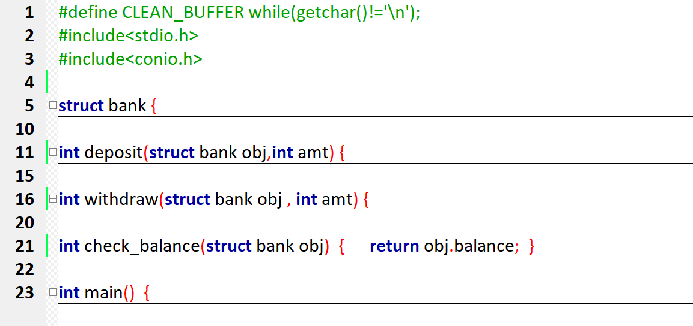

**Code**

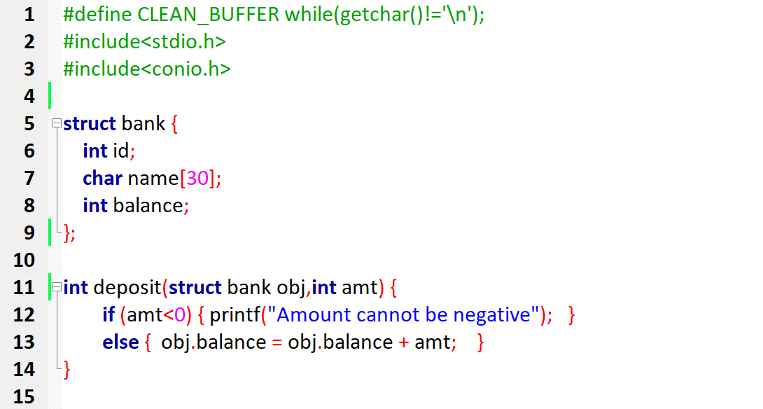

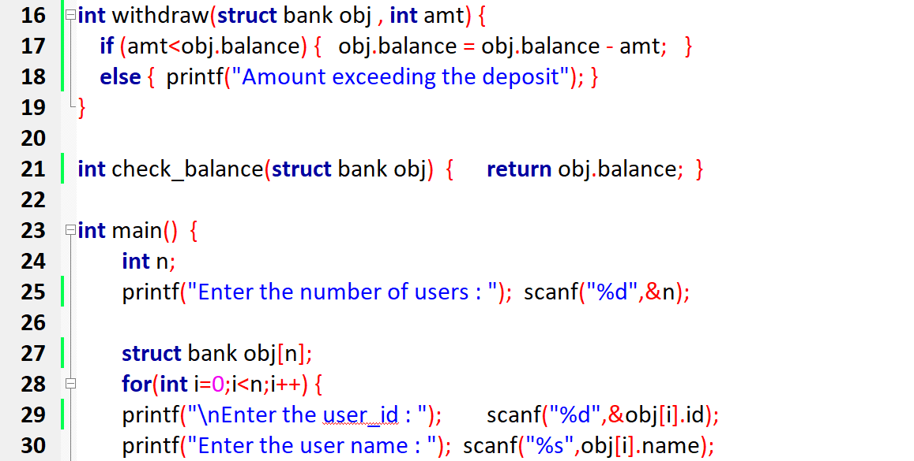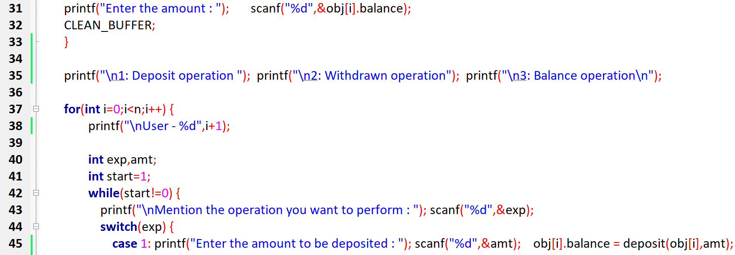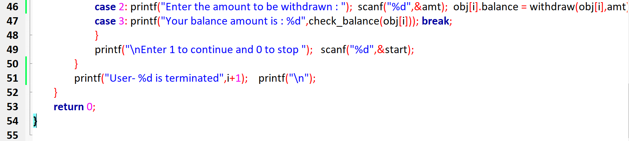

**Output**

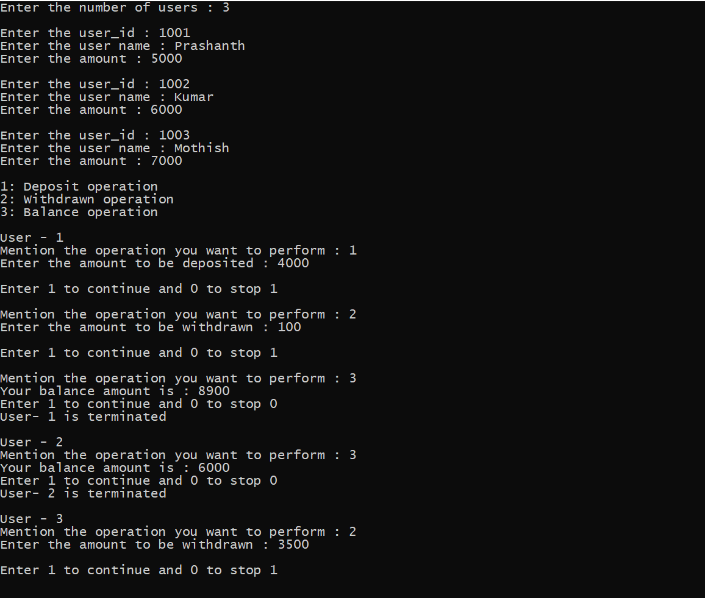

6. Tell me about how efficient your programs are. (1 mark to show up your individuality, answer should be sound and sensible – Answers repeated no marks, so don’t share your answers)

*In the 7th question I used nested recursion, in which a stack within a stack of elements will be created and executed.*

*In 3rd question accessing the array of objects via pointer.*

7. Just for learning: Write a C program to print numbers from 1 to 100 without using loop.

**Program flow**

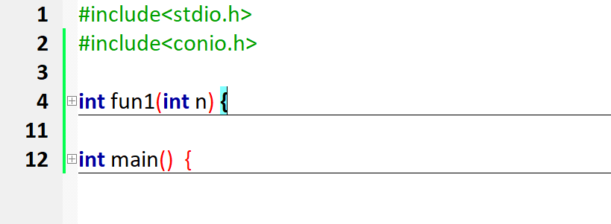

**Code**

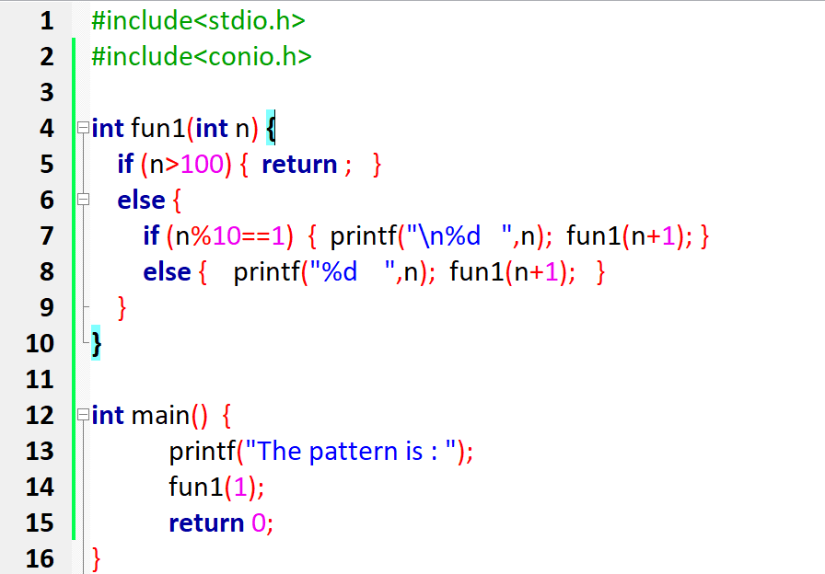

**Output**

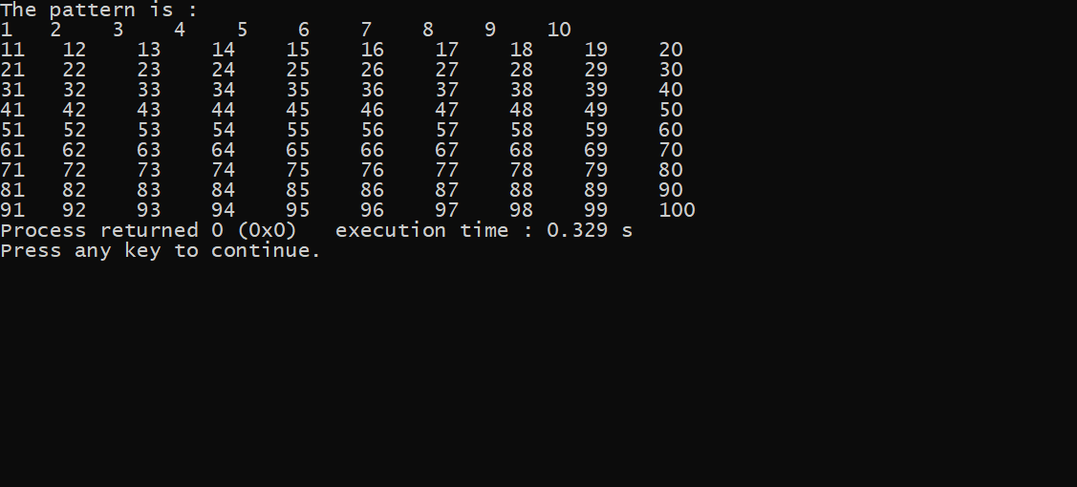

Link to my code <https://github.com/PrashanthSingaravelan/WinterSemester-2021/tree/main/CSE2010%20Advanced%20C%20programming/Lab%20Assignments/Assignment-3>